HARDTACK
Indianapolis Civil War Round Table Newsletter
http://indianapoliscwrt.org/

May 14, 2007 at 7:30 p.m.
Meeting at Indiana History Center

The Plan of the Day

A New Look at Civil War Photography
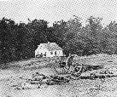
Confederate dead by fence on the Hagerstown Road, Antietam, MD, Sept. 1862
Photographer Alexander Gardner

In the Wake of Battle: The Civil War Images of Matthew Brady

The American Civil War was not the first military conflict in which scènes de guerre were captured for posterity by the camera. It was, however, the first war to be widely documented through photography, often by teams of field photographers working on behalf of both commercial enterprises and the military. Their legacy is a rich archive consisting of thousands of images by which we may peer into a world that has long since passed away.
For our May program, Dave Klinestiver will present an array of period photographs—some familiar, others rarely seen—as he takes “A New Look at Civil War Photography.” Mr. Klinestiver will explain how the introduction of the glass-plate collodion process in the decade preceding the War transformed the photographic imaging industry in America, and made possible the invaluable visual record now available to us. We will consider how this relatively new technology was utilized by the military during the War and how innovative photographers such as Alexander Gardner, Timothy O’Sullivan and A.J. Russell overcame the limitations of their medium to establish photography as a viable and important tool for recording and reporting newsworthy events—the advent of modern photojournalism.
Finally, Mr. Klinestiver will demonstrate how the digitization of Civil War images in high resolution, and the availability of these images to anyone with access to the Internet, has opened a new window on the War of unprecedented clarity and depth—revealing new details of historical interest, including heretofore unrecognized views actual wartime combat.

Our Guest Speaker
Dave Klinestiver

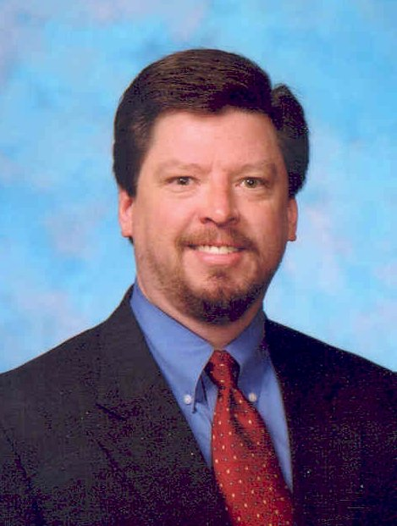
David S. Klinestiver has been a life-long student of the Civil War. He first joined the Indianapolis Civil War Round Table as a teenager more than thirty years ago. As with many buffs, Dave has sought to develop his knowledge and understanding of the Civil War era through a variety of avenues. To supplement his reading and research at home (he is particularly proud of an extensive and ever-expanding personal library of Civil War-related titles), Dave enjoys attending historical seminars and undertaking research trips to archives, museums, private collections and battlefields whenever the opportunity arises (often to the consternation of his family, who thought they were taking a vacation). He has also been a Civil War re-enactor since the age of 14.
Dave graduated from Indiana University in 1981 with a Bachelor of Arts degree in Economics. He earned his Juris Doctorate from the I.U. School of Law (Bloomington) in 1985. After practicing for several years with a large regional law firm in Louisville, Kentucky, Dave returned to his hometown of Indianapolis in 1994. He is presently a director with Lewis & Kappes, P.C., concentrating his practice in the areas of intellectual property, franchise and business law.
Dave and his wife, Eileen Herr, have two children, Daniel, age 12, and Julia, 10.
He is a former editor of the HARDTACK newsletter and is currently serving as ICWRT president for the 2006-2007 campaign.

Roster of Officers and Committees for the 2006-2007 Campaign
Officers:
President: Dave Klinestiver Secretary: Robert Vane
Vice President: Dave Sutherland Treasurer: Peg Bertelli
Librarian: Marilyn Hoffman
Committee Chairs:
Programs: Dave Sutherland Preservation: Andy O’Donnell
Membership: Nikki Schofield Publicity: Dave Buchanan & Tony Roscetti
Quiz Master: Summer Campaign:
Tony Trimble Nikki Schofield
HARDTACK Newsletter:
Editor: Jenny Thompson
Distribution: Jenny Thompson (email) & Tony Roscetti (U.S. mail)

2006-2007 Campaign Plans

This final meeting will be at Primo Banquet and Conference Center. Please see info and reservation form at the back of this Hardtack.
June 11, 2007 Vicksburg Terry Winschel

JOIN US BEFORE THE MEETING AT SHAPIRO’S DELI!
All ICWRT members and guests are invited to join us at 5:30 P.M. at Shapiro’s Delicatessen, 808 S. Meridian St. (just south of McCarty Street) before the meeting to enjoy dinner and fellowship.

Other Camp Activities

Lincoln’s 200th Birthday Celebration: Spectacular events are planned in Spencer County, Indiana to commemorate this upcoming bicentennial. They include: a Mother’s Day Celebration on May 11, 2008 at the Lincoln Boyhood National Memorial; a Civil War Era Ball on September 27, 2008 at the Spencer County Courthouse in Rockport; Catch the Spirit of Lincoln (and his friends and neighbors) at the Haunted Pioneer Village on October 31, 2008 at the Lincoln Pioneer Village; a Reenactment of Lincoln’s Last Visit on November 1, 2008 at the Spencer County Courthouse; a Lincoln Thanksgiving Dinner on November 22, 2008 at the Chrisney 4-H Community Center; a Christmas with Lincoln on December 6-7, 2008 in Rockport and on December 13-14, 2008 in Santa Claus; a Wreath-laying Ceremony Remembering Lincoln on February 12, 2009 at the Lincoln Boyhood National Memorial and the Lincoln Bicentennial Finale on August 5-9, 2009. For more information about these events, visit www.legendaryplaces.org/thinklincoln/default.cfm.

Civil War Public Tour
Nikki Schofield will conduct a Civil War Public Tour on Saturday evening, May 19, from 7:30 to 9:30 p.m. at Crown Hill Cemetery. Because this tour is conducted after the regular cemetery hours, please meet at the 34th Street gate, just off Boulevard Street. The cost is $5.00 for adults and $4.00 for seniors. Attendees will see the sunset from the top of the Crown, which is the highest point of land in the old city limits. Ask Nikki Schofield for details.

Special Orders

WAR ON THE RIVER – Summer Campaign Update
EIGHT PEOPLE NEEDED – We have 28 people registered for the June 16-22 trip to Vicksburg, so we have room for you. There must be 36 people in order to pay the cost of the charter bus. Therefore, eight more people are needed. This will be a good trip, so sign up. We don’t want to cancel for lack of eight people. Nikki Schofield will have flyers at the May meeting. Bring your check for $100 down payment. Total cost is $700 for seven days. Come and join us for “War on the River.”
Test Your Civil War Knowledge (with Trimble’s Trivia)

Identify the Civil War personality known by each nickname below:
- “Gentle Anna” or “Michigan Annie”

- “Neighbor”

- “King Jeff the First”

- “Old Blinkey”

- “Old Blizzards”

Answers to the April Quiz:
1. What unit was known as the “Orange Blossoms”?
124th New York
2. What is an Ellet Ram?
River steamer with a reinforced hull designed to ram other vessels
3. What unlikely location did the Confederacy choose for its Navy Yard after the fall of Norfolk and Portsmouth?
Charlotte, NC
4. Who was “Bluff Ben”?
Sen. Benjamin Wade of Ohio
5. On what battlefield would you find the Bloody Salient? By what other name is this site known?
Spotsylvania; The Mule Shoe

The Soldiers Speak
Visualize the following mental images:

(Quoted from John H. Worsham’s One of Jackson’s Foot Cavalry)
*** A picture during the battle of the Wilderness:
“We were then treated to a rare sight! Running midway across the little field was a gully that had been washed by the rains. In their retreat, many of the enemy went into this gully for a protection from our fire, and when we advanced to it, we ordered them out and to the rear; all came out except one, who had hidden under an overhanging bank, and was overlooked. When we fell back across the field the Yankees, who followed us to the edge of the woods, shot at us as we crossed. One of our men, thinking the fire too warm, dropped into the gully for protection. It will be noticed that there was then a Yankee and a Confederate in the gully, and each was ignorant of the presence of the other! After a while they commenced to move about in the gully, there being no danger as long as they did not show themselves. Soon they came in view of each other, and commenced to banter one another. Then they decided that they would go into the road and have a regular fist and skull fight, the best man to have the other as his prisoner. When the two men came into the road about midway between the lines of battle, in full view of both sides around the field, one a Yankee, the other “a Johnny,” while both sides were firing, they surely created a commotion! This was true in our line and I suppose in the enemy’s line, because both sides stopped firing! When the two men took off their coats and commenced to fight with their fists, a yell went up along each line, and men rushed to the edge of the opening for a better view! The “Johnny” soon had the “Yank” down, who surrendered, and both quietly rolled into the gully, where they remained until night, when “the Johnny” brought “the Yank” into our line. The disappearance of the two men was the signal for the resumption of firing! Such is war!”
*** A picture of the heaviest fighting at Spotsylvania Courthouse:
“We lay down, taking advantage of everything that offered a protection, and opened on the enemy; - musket balls were fairly raining, great limbs of trees were cut off by bullets, as if by an ax, the men seemed more uneasy about them than about the balls. No cannon were used here. This was the heaviest fire the world ever saw at a single point! The fire from those 40,000 men was so heavy that they literally shot trees to pieces! The enemy used mules to bring ammunition on the field, and some of their men fired over 400 rounds, and there is an exhibition at the War Department in Washington an oak tree about fourteen inches in diameter, that was severed by minie balls at this time.”

(Quoted from Soldiering: The Civil War Diary of Rice C. Bull, 123rd New York Volunteer Infantry, edited by Jack K. Bauer)
*** A scene at Harper’s Ferry:
“On the summit was the burial place of forty Confederates who had been killed in the engagement when Harpers Ferry had been captured by General Jackson a few weeks before we arrived. Because the ground was hard and stony the graves had been made so shallow that many of the bodies and even heads were visible. This was a gruesome sight for new soldiers.”
*** Another battlefield scene:
“One of the men whose name was Bill had a very large head, they used to hector him a lot about it. As we lay hugging the ground they could not keep from having their joke on Bill. Jim was constantly teasing him in a good-natured way. He said, “If you don’t look out, that big head of yours will get knocked off; dig a hole for it and drop in the hole, that may be the means of saving your life.” Bill lay quiet and made no answer. Suddenly he jumped to his feet and went for his tormentor. “Now see here,” he said, “I will stand a lot of your talk but I won’t stand for you throwing stones at me.” “Why Bill,” said Jim, “I have not thrown stones at you.” “Well you or someone else has, and I won’t stand for it. I will thrash the man who did.” As Bill was a powerful man and dangerous when angry, the joking ended. That night the stone throwing was explained as Bill unrolled his blanket. He found about twenty holes in it. The blanket had been rolled and strapped to the top of his knapsack, and as he lay on the ground it stood a trifle higher than his head. “Now Bill,” said Jim, “You see I saved your life by telling you to get down.” It was a long time before Bill heard the end of it.”

(Lieutenant Tom Galway, 8th Ohio Infantry, quoted from C. Brian Kelly’s Best Little Stories from the Civil War)
A moment of compassion at the old white oak tree [a haven for Rebel sharpshooters] on the Bliss Farm at Gettysburg, July 3, 1863:
“To the surprise of the Yankees at one point, however, came a pause as one of the Rebs hidden behind the old oak cried out, ‘Don’t fire, Yanks!’
Not knowing what to expect, the Ohioans complied, curious to see what would happen next.
‘A man with his gun slung across his shoulder came out from the tree,’ recalled Galwey. Some of the Union men, angry and grieving over comrades already struck down by the Confederate shooters, took quick aim at this bold enemy, ‘but the others checked them, to see what would follow.’
The Yankees could see that their Reb enemy carried a canteen in his hand as he made his way halfway to the Union line. He stopped then, kneeled, and gently gave a wounded man a drink from the canteen – a wounded Yank!
‘Of course, we cheered the Reb,’ wrote Galwey. Indeed, the Union men by now had risen to their feet, and the Rebs behind their Good Samaritan had stopped firing, too, and were standing in full view. Everybody was now an easy target for their opponents; it was a scenario that could not, and would not, last.
‘As soon as the sharpshooter had finished his generous work, he turned and went back to the tree, and then at the top of his voice shouted, ‘Down Yanks, we’re going to fire.’ And down we lay again.’
Their battle at the foot of the old white oak resumed, and the next day, with Lee’s army now in retreat, ‘a heap of Confederates was found under that tree,’ said Galwey. ‘Whether the hero of the day before was one of the ghastly dead will probably never be known.’”

(Lt. L.R. Mills, 26th Virginia, in a letter to his brother, quoted in The Civil War Chronicle, edited by J. Matthew Gallman)
March 2, 1865, at the siege of Petersburg:
“I would regret very much to have to give up the old place. The soiled and tattered Colors borne by our skeleton Regiment is sacred and dear to the heart of every man. No one would exchange it for a new flag. So it is with us. I go down the lines, I see the marks of shot and shell, I see where fell my comrades, the Crater, the grave of fifteen hundred Yankees; when I go to the rear I see little mounds of dirt, some with headboards, some with none, some with shoes protruding, some with small piles of bones on one side near the end showing where a hand was left uncovered; in fact every thing near shows desperate fighting. And here I would rather ‘fight it out.’”

(Submitted by Vernon Earle, a bit of humor from A Sense of History: The Best Writing From The Pages of American Heritage)
“…The Army legends of those days tell of a Manhattan regiment, camped near Washington, whose nearest neighbor was a regiment from Brooklyn, with which the Manhattanites nursed a deep rivalry. Neither regiment had a chaplain; and there came to the Manhattan colonel one day a minister, who volunteered to hold religious services for the men in the ranks.
“The colonel doubted that this would be a good idea. His men, he said, were rather irreligious, not to say godless, and he feared they would not give the reverend gentlemen respectful hearing. But the minister said he would take his chances; after all, he had just held services with the Brooklyn regiment, and the men there had been very quiet and devout. That was enough for the colonel. What the Brooklyn regiment could do, his regiment could do. He ordered the men paraded for divine worship, announcing that any man who talked, laughed, or even coughed would be summarily court-martialed.
“So the clergyman held services, and everyone was attentive. At the end of the sermon, the minister asked if any of his hearers would care to step forward and make public profession of faith; in the Brooklyn regiment, he said, fourteen men had done this. Instantly the New York colonel was on his feet.
“‘Adjutant!’ he bellowed. ‘We’re not going to let that damn Brooklyn regiment beat us at anything. Detail twenty men and have them baptized at once!’”

(Quoted from Thomas Wentworth Higginson’s Army Life in a Black Regiment)
An event that occurred during skirmishing near Jacksonville, Florida:
“It was at this time that the small comedy of the Goose occurred, -- an anecdote which Wendell Phillipps has since made his own.
One of the advancing line of skirmishers, usually an active fellow enough, was observed to move clumsily and irregularly. It soon appeared that he had encountered a fine specimen of the domestic goose, which has surrendered at discretion. Not wishing to lose it, he could yet find no way to hold it but between his legs; and so he went on, loading, firing, advancing, halting, always with the goose writhing and struggling and hissing in this natural pair of stocks. Both happily came off unwounded, and retired in good order at the signal, or some time after it; but I have hardly a cooler thing to put on record.”
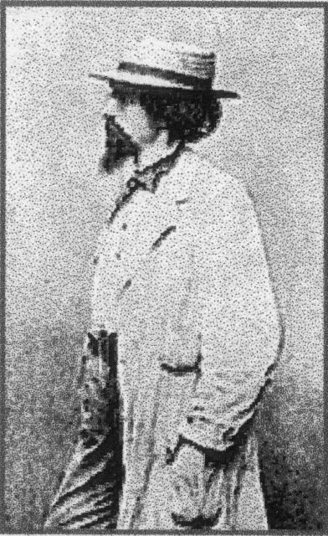
Civilian of the Month

Matthew Brady
Matthew Brady was born in 1823 in Warren County, New York. He was the son of Irish immigrants. He was sixteen when he arrived in New York City and took a job as a department store clerk. He also started his own business manufacturing jewelry cases. In his spare time, he studied photography under a number of teachers. By 1844, he had his own portrait studio in New York City, producing photographs of the famous. He was considered one of America’s greatest photographers. In 1856, he opened a studio in Washington, D.C. to make it easier to photograph leaders and foreign dignitaries.
Brady also used photography to chronicle national history and turned his attention to the Civil War. He organized and supervised a corps of traveling photographers (who followed the troops in the field), provided darkroom carriages, preserved their negatives, kept detailed records, and bought other photographs from private photographers – all at his own personal expense (about $100,000). When his collection of photographs was published, he received the credit, although it was the work of many photographers.
Brady shocked America in 1862 when he displayed photographs of corpses on the battlefield of Antietam in his New York gallery; this was the first time many had ever witnessed the carnage of war. After the Civil War, people were no longer interested in war photos. Brady fell into bankruptcy. Congress purchased his entire archive of 5,712 negatives in 1875 for $25,000 (not the $125,000 Brady had requested). His debts took that whole amount. He died penniless and unappreciated in 1896. Brady’s work provided the first comprehensive photo-documentation of a war.

Historic Site of the Month

Indiana History Center


In 2003, the Indiana Historical Society, with the $2.9 million financial support of the Lilly Endowment, Inc., purchased three Abraham Lincoln collections – the Jack Smith Lincoln Graphics Collection, the Daniel R. Weinburg Lincoln Conspirators Collection, and the Alexander Gardner Lincoln Glass Plate Negative. These collections are featured in a permanent rotating exhibition on the fourth floor of the Indiana History Center. The seventh rotation of The Faces of Lincoln, “Lincoln and the Printed Image/Myth,” will be on view from April 14 through August 24. It features photographs and prints of Abraham Lincoln showing him as the Civil War president, a martyr, emancipator, preserver of the country and a family man. Digital images of these items and information about these collections can be viewed online at http://www.indianahistory.org/library/digital_image/digitalpics.html.

Marching at The Double Quick
By John J. Copeland

In the hills, woods and rolling fields
The scars on the landscape
Time always heals

The four seasons abound in splendor
Sounds of distant marching armies
Must be imagined
No one marching then
Is here now to remember

The ridges and hills near a sleepy
Pennsylvania town
Seminary and Cemetery Ridges
Big and little Round Tops
Each with artillery on its crown

Each elevation covered their trees
Scatter their leaves to the ground
cut from branches by shot and lead
Buzzing like a million bees

Regiments of soldiers
Marching at the double quick
No stragglers – close up the ranks
Carry the rifle at right shoulder shift
Marching at the double quick.

Closer and closer to the enemy they come
Retreat! Out of the question
No soldier wavers – None will run
Into the valley of death
Still marching at the double quick

Flesh vs. Iron
Puddles of blood and human wreckage
accouterments of war
A tall black hat of the Iron Brigade
with its ostrich plumage

Then all is silent save for the cries
of the wounded
The result of battle is death and
destruction

A battlefield is hallowed ground
For time eternal
Long after the solemn notes of Taps
Have been played
The bugle is silent after the sound

In the hills, woods and rolling fields
The scars on the landscape
Time always heals
Marching at the double quick

If you have a short article, book review, or some other item that may be of interest to our members, please submit it via email to the editor at jkt60@earthlink.net by the tenth day following the preceding month’s meeting. Please list HARDTACK in the subject line and include your email address in case I need to contact you.

Re-enlist NOW for the 2007-2008 Campaign and save 5.00!!

Membership dues for the 2007-2008 campaign of The Indianapolis Civil War Round Table
will increase by $5.00 effective July 1, 2007
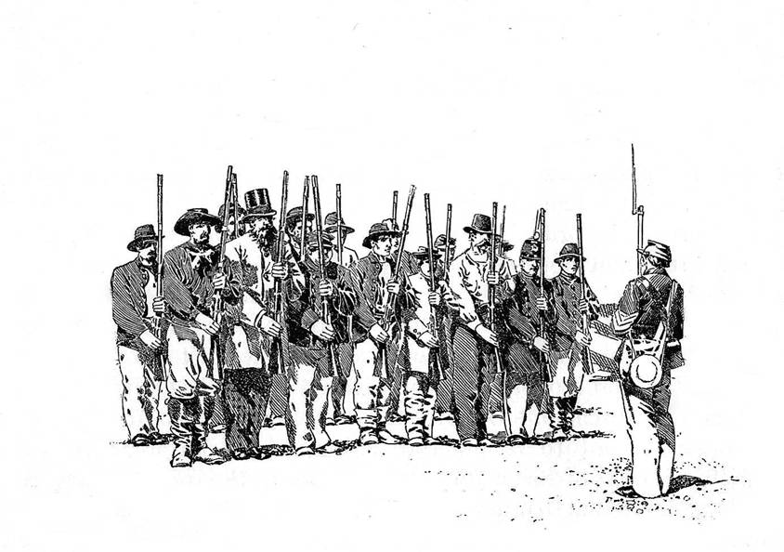
Beat the dues increase by re-enlisting NOW at current rates!

To encourage early re-enlistments, the ICWRT is extending a $5.00 discount on all new or renewal memberships for next year that are received by the end of June. This discount will effectively offset a $5.00 dues increase applicable to all membership levels for next season.

All ICWRT members may continue to receive the monthly newsletter, HARDTACK, via email at no additional charge. Members who prefer to receive the HARDTACK by U.S. Mail are asked to pay an additional $12.00 to help cover printing and mailing costs.

Please bring your completed re-enlistment form (below) together with your payment to Peg Bertelli, ICWRT Treasurer, at the next Round Table meeting, or mail your re-enlistment form and payment to:

Peg Bertelli
11827 Corbin Drive Phone: (317) 596-9193
Fishers, Indiana 46038 Email: pbbertelli@insightbb.com

Please complete and detach the form below and include with your check:
-------------------------------------------------------------------------------------------------------

ICWRT Membership Enlistment for July 2007 thru June 2008
Please print legibly!

Name…………………………………………………….…. Date ………………..

Address……………………………………………………………………….

……………………………………………………………………….

Phone: (………) …………………… Email Address: ……………………..………..

We must have a valid email address if you wish to receive the HARDTACK newsletter free of charge!

Discounted Dues for the 2007-2008 must be paid by June 30, 2007* (please specify Membership Level):

_____ $25 Individual (reg. $30) _____$30 Family (reg. $35) _____ $10 Student (reg. $15)

* If paying after June 30, 2007, please pay the regular dues amount as shown above

______ I wish to receive the newsletter via U.S. Mail for an additional $12

In addition to my membership dues, please accept my generous gift of $ _________
to the ICWRT general operating account (This donation is not tax deductible)

Individuals attending the Indianapolis Civil War Round Table, June 11, 2007 dinner meeting:

Name Name

Reservation form and payment must be received by June 1, 2007.

Cost: $20 per person. Please make check payable to Indianapolis Civil War Round Table. Payment and this reservation form can be brought to the April or May Indianapolis Civil War Round Table meeting or mailed to Peg Bertelli, and must be received by June 1, 2007.
************************************************************************

Please detach and mail this form, along with payment, to Peg Bertelli

Indianapolis Civil War Round Table
Annual Dinner Meeting

June 11, 2007
at

Primo Banquet & Conference Center *

5649 Lee Road, Indianapolis, Indiana 46216
(317) 545-5499

Cost is $20 per person
Buffet dinner will be served starting at 6:30 PM and includes:
- Entrées: Roast Beef Au Jus or Chicken Marsala
- Sides: Italian roasted potatoes or Vegetable Medley
- Salads: Tossed Salad or Pasta Salad
- Dinner rolls with butter
- Iced tea or coffee
Our Guest Speaker: Terry Winschel
* Directions: Take 56th Street east from I-465 on the east side of Indianapolis. Take a left on Lee Road, which is the traffic signal immediately before the railroad overpass (on the grounds of the former Ft. Benjamin Harrison). Primo is on your immediate right. Take the second right off Lee Road (this is the North entrance to Primo).
Reservation form (attached above) should be completed and submitted, along with payment, by June 1, 2007. Reservation form and payment can be brought to the April or May meeting or mailed to:

Peg Bertelli

11827 Corbin Drive
Fishers, Indiana 46038

